The Time it takes Salt Water to Boil!

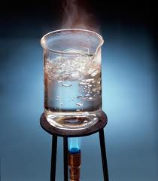

Yuki Aoki
December 19, 2013
Science Fair Project
Science teacher Mrs. Morra
Homeroom - 201
SAMPLE LAB REPORT
Title: The Time it takes Salt Water to Boil
Question: Does salt water reach 100°C at the same speed as tap water?
Background Information/Research Paper:
My experiment is about how salt affects the boiling point of water. My hypothesis is going to be that if I compare regular tap water to salted water then I'm going to find that salted water boils sooner. My independent variable is adding salt, my dependent variable is the time it takes to boil. I chose this experiment because I've noticed that when my relatives cook, and even on cooking shows on television, they sometimes sprinkle a bit of salt into the water. I always thought this was for the taste. But lately I had heard it's to make things go faster so I wanted to investigate that idea.
The heat capacity of water is very high. What this means is that it takes a lot of energy to raise the temperature of water 1°C; in fact, the calorie is defined as the amount of energy that it takes to heat one gram of water to 1°C. Not to digress, but the high heat capacity of water is good, especially if you live on a planet where two-thirds of the surface is covered by water - it helps regulate the global temperature
The time it takes a bucket of liquid to boil is controlled by essentially three things. The first is how much heat or energy you put into the bucket. The second is how fast the temperature rises in response to the heat input (the liquid's heat capacity), and the third is the boiling point of the liquid.
If you look at the heat capacity of salt water, you will find that it is less than pure water. In other words, it takes less energy to raise the temperature of the salt water 1°C than pure water. This means that the salt water heats up faster and eventually gets to its boiling point first. This could matter in real life in situations like restaurants where they need to cook a large amount of food for many people.

(see my works cited on the last page)

Hypothesis: If I compare the time it takes tap water and salt water to come to a boil at 100 degrees Celsius' then I will find that salt water will reach 100°C more slowly than tap water because salt water has a lower heat capacity than tap water.
Materials:
2 beakers 2 Bunsen Burners
2 tripods 2 stop watches
2 thermometers
Procedure(Directions):
Variables:
Independent: Amount of salt
Dependent: Time measured in seconds
Controlled: Amount of water; temperature of the Bunsen burner flame
1. Fill both beakers with 200ml water from the tap.
2. Add 5g salt to one of the beakers
3. Turn on both Bunsen burners at same time.
4. Turn on both stop watches.
5. Use thermometers to measure the temperatures in both beakers.
6. Record the time when the temperature reaches 100°C.
7. Repeat 1-7 above with 10g, 15g, 20g salt.

Results:
Amount of Salt (in grams) | Time to 100°C (in seconds)
0 | 160
10 | 151
15 | 148
20 | 142

Graph/Analysis:

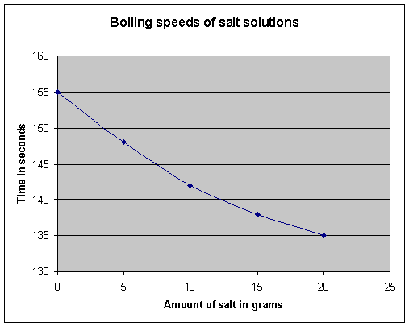

Conclusion and Discussion:
I would have to reject my hypothesis - it was incorrect. In fact, the opposite is true: the more salt there is in the water, the more quickly the water reaches 100°C. This is because salt water has a lower heat capacity? If you look at 100 grams of pure water, it contains 100 grams of water, but 100 grams of 20 percent salt water only contains 80 grams of water. The other 20 grams is the dissolved salt. The heat capacity of dissolved salt is almost zero when compared to the high heat capacity of water. This means that the heat capacity of a 20-percent salt solution is 80 percent that of pure water. Twenty percent salt water will heat up almost 25 percent faster than pure water and will win the speed race to the boiling point. The experiment was easy to understand and to do for two students working together. However, there was a problem with controlling the two Bunsen burners to make sure they burned at exactly the same temperature. If I repeated this experiment I would use hot plates instead so that control over the temperature could be more exact and reduce error.

Acknowledgments: I want to thank my lab partner, parents, and science teacher for helping with getting the materials, and the setting up of my lab.

References - Works cited:

http://www.iapws.org/

http://www.swri.org/10light/water.htm

